Introduction

As the rapid development of E-commerce such as Amazon, Alibaba and eBay, the parcel

Related Work

System Design

3.1 System Overview

This thesis designs a self-driving delivery simulation system, as illustrated in Figure 3.1, the system consists of five components, including the mobile application, the TraCI server, the SUMO simulator, the back-end server, and the database. In this system, the mobile application is a platform which can let the user place a delivery order for shipping cargos and track the user’s orders. After a user issues a delivery request on the mobile application, it will be sent to TraCI server. The server will do the dispatching mechanism to assign a truck which meets the conditions to receive the cargo, and it will be displayed on SUMO simulator by TraCI commands. Moreover, the data about order’s information will be uploaded to the database if the assignment is successful, and the user can view the order’s status on the mobile application by connecting to the back-end server. When the truck arrives at the address of shippers or receivers on the simulator, the TraCI server will send a message to the mobile device to notify the user of this event through a cloud messaging service. Moreover, the server will also send a message to notify the receiver that the pickup time of the cargo can be selected already when the truck has arrived at the sender’s address. All the simulated process can be observed on the SUMO simulator. The features of each component will be described in detail in the following sections.

3.2 Mobile Application

In this system, the main object to develop the mobile application is to simulate the real user scenario. The features of the mobile application include registration and login of the user accounts, placing the delivery order, and tracking established orders. The function of each part is depicted as follows.

3.2.1 Registration and Login

When the mobile application is launched for the first time, a token will be generated. If a user sign up and sign in his/her account, the token will be uploaded to the database. The TraCI server can send a notification to the mobile device by this token while the truck arrives at the target. On the other hand, the user-related data like username will be stored in the device’s memory when the user sign in, and it can be used to generate the delivery order and track the user’s orders. The process will be described in the next two segments.

3.2.2 Placing the delivery order

In order to simulate the real user scenario, we implement a function that the user can place an delivery order. First, the user needs to fill out the order’s information which includes size, receiver’s username, sender’s address, receiver’s address, and so on. Then, the address will be displayed by google map service so that the user can confirm the correction of location. After that, the user can choose the arrival time of the truck, and send the delivery request to the TraCI server. The request contains user-related data and order’s information, and the server will do the dispatching mechanism by these information and the road condition of the SUMO simulator. The order will be uploaded to the database if the request is accepted. Otherwise, the TraCI server will return a error message to the application to notify the user that there are no trucks can arrive the address at the appointed time.

3.2.3 Tracking Established orders

After the order is established successfully, the user can track the orders’ status by using the function of tracking orders. In this function, the user can examine the orders which were sent by himself or others. Besides, if the user is a receiver, he can choose the pickup time of the cargo after the truck arrives at the sender’s address. In our view, the receiver should select the pickup time only after loading of the cargo because the system must ensure the cargo is ready to be delivered. In addition, the system provides a function to examine the orders by inputting the order number instead of login. It let the administrator can search all orders of users conveniently on the mobile application.

3.3 TraCI Server and SUMO Simulator

In our system, the TraCI server is response for receiving the user’s requests of delivery, doing the dispatching mechanisms, uploading and updating the order’s information of users, and communicating with the SUMO simulator to get the data of road conditions and dispatch the truck on the simulator. This thesis deals with processing of received data and uploading data of order’s information to the database.

　　As illustrated in Figure 3.2, after the user places an order with the TraCI server, the order’s data will be stored in a queue of the dispatching requests. The socket program can know the request whether it is sent by a sender or a receiver according to the data, and it will store extra information like the truck number and the container number if the request is sent by a receiver. It is because that the server needs to know which trucks to be dispatched. The server will check the queue continuous, and do the dispatching mechanism if there are any requests in it. If the dispatching is successful, the server would insert or update the order’s information to the database by the database API and send a message to the mobile application through the socket. Otherwise, the server will notify the user that this arrival-time is unavailable by another message. Moreover, the TraCI server will change the dispatching schedule table on the basis of the above result, and it will do the corresponding commands to the SUMO simulator so as to change the selected truck’s route.

　　After the delivery tasks are assigned to the trucks, they will drive along the designated routes, and the system administrator can observe the trip and the parking place of each truck in the simulator. When a truck arrives at the target, the TraCI server will send a notification to the mobile device through the cloud messaging service to simulate the real situation. Then, after five minutes, the server will simulate the uploading and unloading of the cargo, and it will also notify the receiver that the arrival time can be selected if the target is a sender’s address. All of the above event will change the order’s information, and the server will update it to the database in each time. These changes can be observed on the mobile application by using the feature of tracking orders. Finally, the status of the order will be set to “received” by the server instead of being deleted when the delivery is over. Hence, the records of users’ order can be viewed on the database or the mobile application. The implementation of the cloud messaging service will be described in Chapter 4.

3.4 Back-End Server

The SUMO server would spend much time executing the dispatching mechanism and simulating the package delivery process, and it will cause the computing delay. To keep the simulation precise, the gap between simulation time and actual time has to be shorten. Hence, the thesis builds back-end server in order to reduce the workload of the SUMO server. In system, the back-end server is in charge of communicating between the mobile application and the database. It provides a interface by which the user can query or insert data to the database. The works of the back-end server include handling login and registration of user accounts, querying the order's data when the users track their orders, and showing the data of cities, counties and townships when the users are filling in an order form.

The mobile application accesses to the database through the SUMO server only if users place a delivery order, so the process can reduce the computing burden of communication on the SUMO server as much as possible. The next section will introduce the design of data formats which are used when the back-end server executes the commands of database.

3.5 Database

As discussed above, the simulation-related data in the system are stored in the database. The database is composed of four tables, they will be described and discussed in this section.

　　The first table named user-table keeps the account information of registered users. Table 3.1 shows the data format of user-table. As mentioned in chapter 3.2.1, the attribute “device_key” is the token generated by the application. The token is assigned to the mobile device rather than the user, and it will be updated when the user logins on different devices. Therefore, the SUMO server can know which device is bind to the user by the unique token. The attribute “username” is applied to identify the user who places the order.

　　The second table and the third table are county table and township table. The data format of the two tables is presented in Table 3.2, Table 3.3. The administrative district data of Taiwan is stored in the both tables. the data will be shown on the mobile application when the user wants to select the address of the shipper or receiver. Therefore, the typo can be reduced so that the process of geocoding can be performed better. The geocoding technology will be mentioned in Chapter 4. Furthermore, it provides scalability of service region, if the range of the simulation becomes larger, the administrator can easily expand regional options by adding additional data to the database.

　　The last table is order table. As shown in Table 3.4, it retains information of the user’s order, and part of order will be explained in this section. The attribute “status” represents the situation of logistic activity, such as "on the way to the receiver’s address”. In addition, it is the criteria whether if the receiver can designate the arrival time. The attribute “sender_name” and “receiver_name” are used by the SUMO server to determine users which the server will notify. The latitude and longitude transformed from senders’ addresse is stored as “sender_lat” and “sender_lng”, and the same is true for the receivers’ addresses. The attribute “sender_time” and “receiver_time” are the expected arrival time that users select on the mobile application. The SUMO server will exploit the locational and time information to generate a dispatching schedule and arrange the route of each truck.

System Implementation

4.1 Mobile Application

Among all mobile operating systems, Android OS holds 86.7% market share according to the survey.[] It is the most widely-used operating system in the world. Given that the self-driving delivery will be popularized in all walks of life soon after, Android OS is the most suitable system for developmentthe mobile application. The application is built by the Android Software Development Kit (Android SDK), and it is developed on Android Studio which is Integrated Development Environment for Android. Android Studio provides a preview of the user interface and it has the built-in support of Google Cloud Platform. Consequently, it is an appropriate way to construct the mobile application of the system. Furthermore, Google Map SDK for Android and Google Geocoding API were added to the mobile application, the former enables the application to display the map of simulation and mark the address, the latter is able to transform the street address into latitude and longitude.

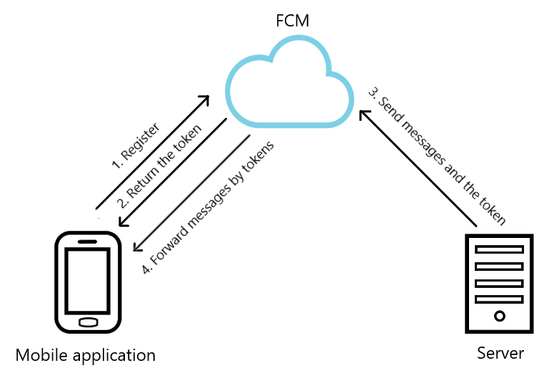

　　In order to send the messages to notify the users that the truck has arrived to the destination , a cloud solution for messages and notifications is included in the self-driving delivery system. Firebase Cloud Messaging (FCM) is a service provided by Firebase, which is a subsidiary of Google, and it facilitates messaging between the mobile application and the server built by developers.

As illustrated in Figure 4.1, there are three components such as mobile application, FCM, and the server. The mobile application involves in the process of message passing.

FCM and the server that intends to send notifications (i.e., TraCI server in this thesis).

When the mobile application is installed on the mobile device and launched for the first time, the apps will send a registration request to FCM through FCM SDK. Then, the FCM server will generate a corresponding token for the device, and return the token back to the mobile application. The token would be uploaded to the database if users log in. Conversely, when users log out, the token in the database will be removed to prevent the server from notifying the wrong users. According to the tokens stored in the FCM server, the messages sent from the TraCI (Traffic Control Interface) server will be forwarded to the appointed device by FCM.

　　The user interface of the mobile application is illustrated in Figure 4.2. As shown in Figure 4.2a, the homepage of the application is constituted by the buttons of the main functions. The study developed a simple registration function of user account, which is shown in Figure 4.2b. Before a user logs in, the FCM token is stored in the memory of the device. The user can be distinguished in different mobile devices with the unique toke after logging in.

Figure 4.2c depicts the page of placing a package delivery order, the user must fill in all the fields of the order. The option of container size can be expanded based on the container type of the logistics companies. The user can press the region selecting button to get the administrative district of the simulation range, which is shown in Figure 4.2d. This function make the user input data faster and reduce the typing errors. The simulation range in this thesis contains parts of Tainan City.

For the sake of convenience, the application will record the data entered by the user last time, and the data will be filled in the order automatically when clicking the auto inputting button. After filling out the order information, the user can presse the next button, and the application would check whether the user name of receiver exist.

As illustrated in Figure 4.2e, the address that the user input will be transform into geographic location, and the shipper’s address will be displayed on the Google Map so that the user can confirm if the localization is correct. Then, the user can use the dropdown list to select the arrival time of the truck. Finally, the order request will be sent to the SUMO server by socket program. If there are eligible trucks in the simulated environment, the server would return a success message. Otherwise, the page will not be closed, and the user can choose other expected arrival time.

　　The established order can be viewed on the page of tracking orders shown in Figure 4.2f. This page has two cases. First case is to check the parcels the user sent. After sliding the tabs above the page, the user switches into the second case. The second case is to examine the history packages which the user received.

Then, the detailed information would be displayed while the user clicks an order, which is shown in Figure 4.2g.

If the user is a receiver in an order, he can choose the pick-up time of the cargo according to the status of logistic activity, which means the shipping situation of the cargo. The page is the same as Figure 4.2e.

Besides, if a system administrator wants to examine the orders of different users, the last function in the application can be utilized.

Figure 4.2h exhibits the order searching page, the order can be looked up by entering the order number.

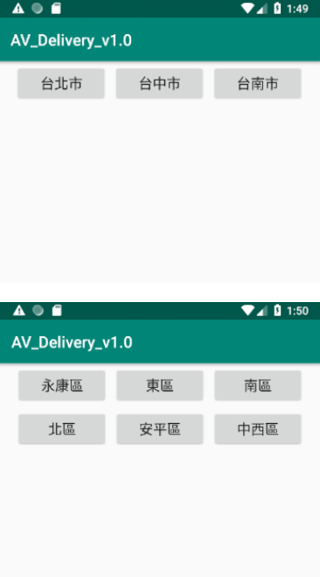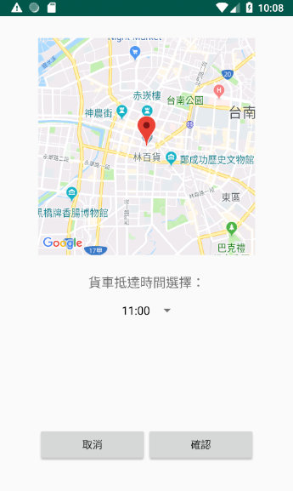

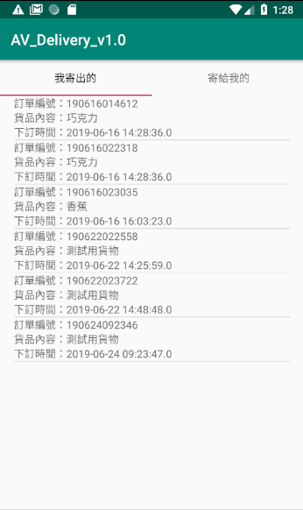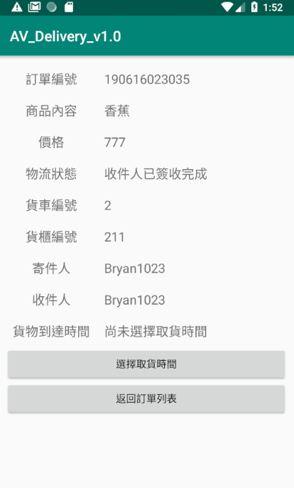

4.2 SUMO Server and Simulator

**4.2.1 Simulation Environment Setup**

The simulation of the delivery process is implemented on SUMO[], “Simulation of Urban Mobility”, which is an open source, highly portable, microscopic and continuous traffic simulation package. The example of roads, vehicles, junctions and other road information are included in the package, and there is the graphical simulator certainly. TraCI is an interface that provides the access to SUMO simulator by using a TCP based client/server architecture. It was implemented in various programming language, such as Python, C++, Java, and so on. In this thesis, TraaS is employed to be the control interface of the simulator. It is a java library for working with TraCI, and it provides plenty of commands to manipulate the simulated objects. For instance, the developer can change the route of a vehicle by certain commands.

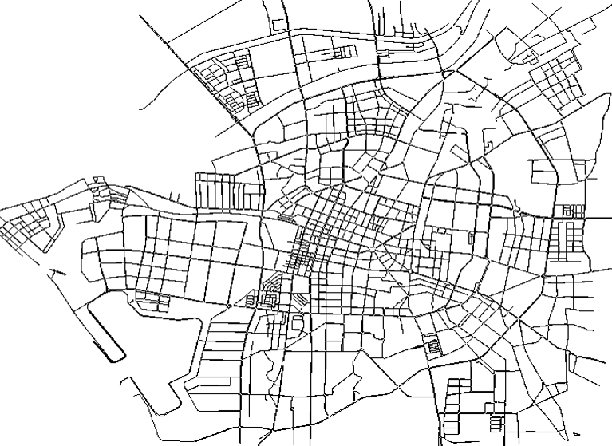

The self-driving delivery system is designed to supply a small-scale package delivery service in cities. As illustrated in Figure 4.3, the road network environment of simulation is an approximate 50 km2 area, which is a partial region of Tainan, a city of Taiwan. The resource of the map data is gained from OpenStreetMap, which is a is a collaborative project to create a free editable map of the world. There are 25069 road segments and 6785 junctions in the simulation, and the traffic lights are deployed on the junctions using the real world data. In the beginning of the simulation, three trucks are generated on the roads randomly, and they drive along random routes until the end of the simulation. The maximum speed of trucks is set to 5 m/s according to the average speed estimated by Google Map. The delivery task can be assigned in any time.

**4.2.2 Build the Socket Server**

For purpose of communicating between the mobile application and the simulator, the thesis built a SUMO server to receive the data transferred from the mobile device which makes the simulator perform delivery task. The SUMO server is composed of a socket server and a main simulated program, which are both developed in Java language. This thesis copes with the socket server part and operations of database API.

When the simulation starts, the socket server will listen to the incoming connections from mobile applications. The socket server is programmed with a multi-client architecture, and the demand can be coped in a short period of time. Hence, the system can serve considerable users simultaneously. The user’s request will be stored in the request queue when the user connects to the socket server, and the data format of the request is represented by JSON (JavaScript Object Notation). The simulated program would check the queue in each simulation second. If there is any request, it will be forward to the dispatching mechanism.

The order information would be uploaded to the database using JDBC if the dispatching execution is successful. JDBC (Java Database Connectivity) is an API for Java to access the database. The database and the SUMO server are built on the same computer because of the security concern. Then, the data can be transferred directly to the local side. The simulation process will display on the GUI of the simulator so that the system administrator can confirm the information of trucks and containers. After the dispatching command is appointed to the truck, the truck will follow the new route. The changes of routes and the parking places can be observed on the GUI, which is shown in Figure 4.4.

Moreover, the FCM service is also implemented in the SUMO server, it would send the message to users through the FCM server using the token acquired from the database.

4.3 Back-end Server

To avoid the leakage of sensitive information of the database, users can not connect to the database directly. Thus, the system takes the back-end server as an interface to access to the database. The back-end server is a web server, which is built using Apache HTTP Server. The service which receives query requests from users, and the service is implemented with PHP program.

The mobile applications connect to the back-end server by HttpUrlConnection. It is Android function which makes the application communicate with the web server by HTTP protocol. According to the HTTP URL, the web server would run the PHP program to execute the SQL commands of the database. The result returned from the database will be forwarded to the mobile application by the web server.

4.4 Database

The database of the system is developed with MariaDB 10.1.32. MariaDB is a community-developed, commercially supported fork of the MySQL relational database management system. It inherits the advantages of MySQL. Hence, MariaDB supplies the JDBC driver, and the database API for PHP. This is highly useful for the development of our system. To deal with the administration of the database, phpmyadmin is employed in this thesis, it is a graphical, free and open source tool written in PHP. It allows the developer to manage the database with the use of a web browser. The records of orders can be exported for the subsequent data analysis.

The current goal of the system is to achieve the urban-wide delivery. Therefore, the information of the administrative districts is stored in county table and township table of the database. There are three cities in county table currently, including Tainan City, Taichung City, and Taipei City. In the simulation of this thesis, only the map of Tainan City is constructed in the simulator, and the simulated districts involve East District, West Central District, North District, South District, Anping District and Yongkang District. The data are referenced from the Ministry of the Interior’s Open Data (MOI Open Data).

Conclusion and Future Work

5.1 Conclusion

In order to make the self-driving technology development companies have a platform to test and adjust the product to meet the market before the product is officially online. Then, a system was designed and implemented to simulate the freight process of the self-driving delivery. This thesis handled the developing of a mobile application and the data transmission between apps and the simulation system. In terms of the mobile apps, an account system was accomplished to store user information, and the order functions were devised to send and display orders. For the purpose of performing the dispatching mechanism, SUMO server must be able to interact with mobile apps. Therefore, a socket server was built to receive and handle the data sent by apps. For similar reasons, FCM service was also be included in the system, and it can assist SUMO server in notifying users of mobile apps. As regards the database, a back-end server was built to supply the access to interface of the database and the mobile apps. Moreover, SUMO server transfers data to the database directly because the SUMO server is on the inner server side.

5.2 Future Work